Why Companies can’t ignore IT outsourcing in 2020
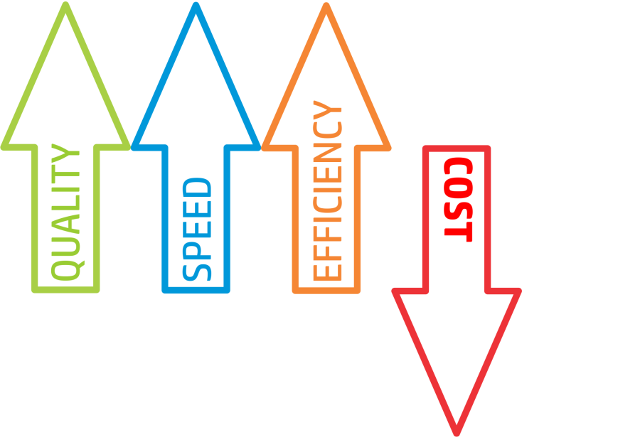
It is that time of the year again where everything new begins, and businesses look forward to redefining themselves. The year 2020 is going to be quite a transforming one for those who will consider IT outsourcing for many reasons. Opting to do so means tapping on the opportunity to refine business strategies and integrate processes that make business matter. One of the best ways to bring about change in business is through IT outsourcing.
Globally, managed IT service witnessed a spend of around 85 billion dollars in 2018, with more than 1/3rd companies preferring to outsource their IT. And now, in the coming year, it is expected to shoot up with more companies looking to leverage available technology and experts without the need to invest in from scratch.

There are more investments in tech start-ups to promote innovation. Recently, Pegasus Tech Ventures came up with Venture Capital as a Service (VCaaS) to enable fund management for global corporations. It has over a billion dollars in assets under management across its funds that span 30+ MNCs, including the likes of Sega, Asus, etc. While Pegasus is just one company, there are many more investing or planning to do so in 2020.

There are three key reasons why companies cannot overlook IT.

- Enable Quick Scaling Up


Most small businesses need to re-structure their IT over time. Getting new technology is inevitable with growing business services and teams. With outsourcing IT to the experts, you enable quick scaling up and leverage technology better for your business. And even if the IT needs to keep changing, the managed IT provider is equipped with people and technology to help you stay dynamic and make scaling up seem effortless.

- Access to New Technology: Cloud Computing

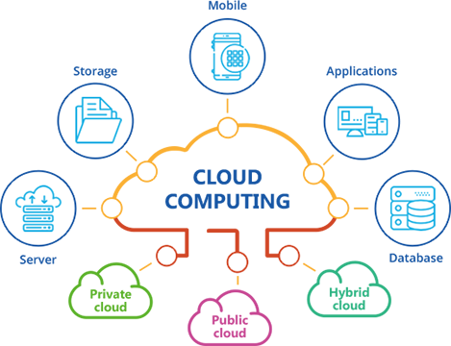
Shared IT solutions are the way to go for small businesses that cannot afford to invest in the latest technology. And one of the core technology that helps scale small businesses is clout technology. It makes way for scalable process automation as you will out the money in innovation and not merely the people. Cut all the hassles of space and time with outsourced cloud computing to leverage tools that matter most to your business growth.

- Take your Business Global


Every business wants to write its own growth story, and no such account is complete without global growth. And such growth means working across different time zones. Managing such scalability will require outside assistance from IT experts. For example, team ExpandForce has clients from all over the world who keep us up and running 24x7, 356 days. Such a dedicated team ensures your IT systems stay updated and work smoothly even when you are asleep. Getting a crew on board who work for your clients in your absence is the first step towards shaping up a global business.

You and your employees should be focusing on serving customers better and give them what they need. Taking your focus away from the core business and channelizing it for IT may hamper your brand. It is best to do away with such hassles of managing the technology all by yourself.

Choose ExpandForce, an experienced IT service provider with a team passionate about top-notch providing customer care. Call: (954) 271-5970 today!

