Jobs
Initiator
- At present, I can select upto 3 sectors while posting a job vacancy. Screenshots of groups of sectors are provided below:
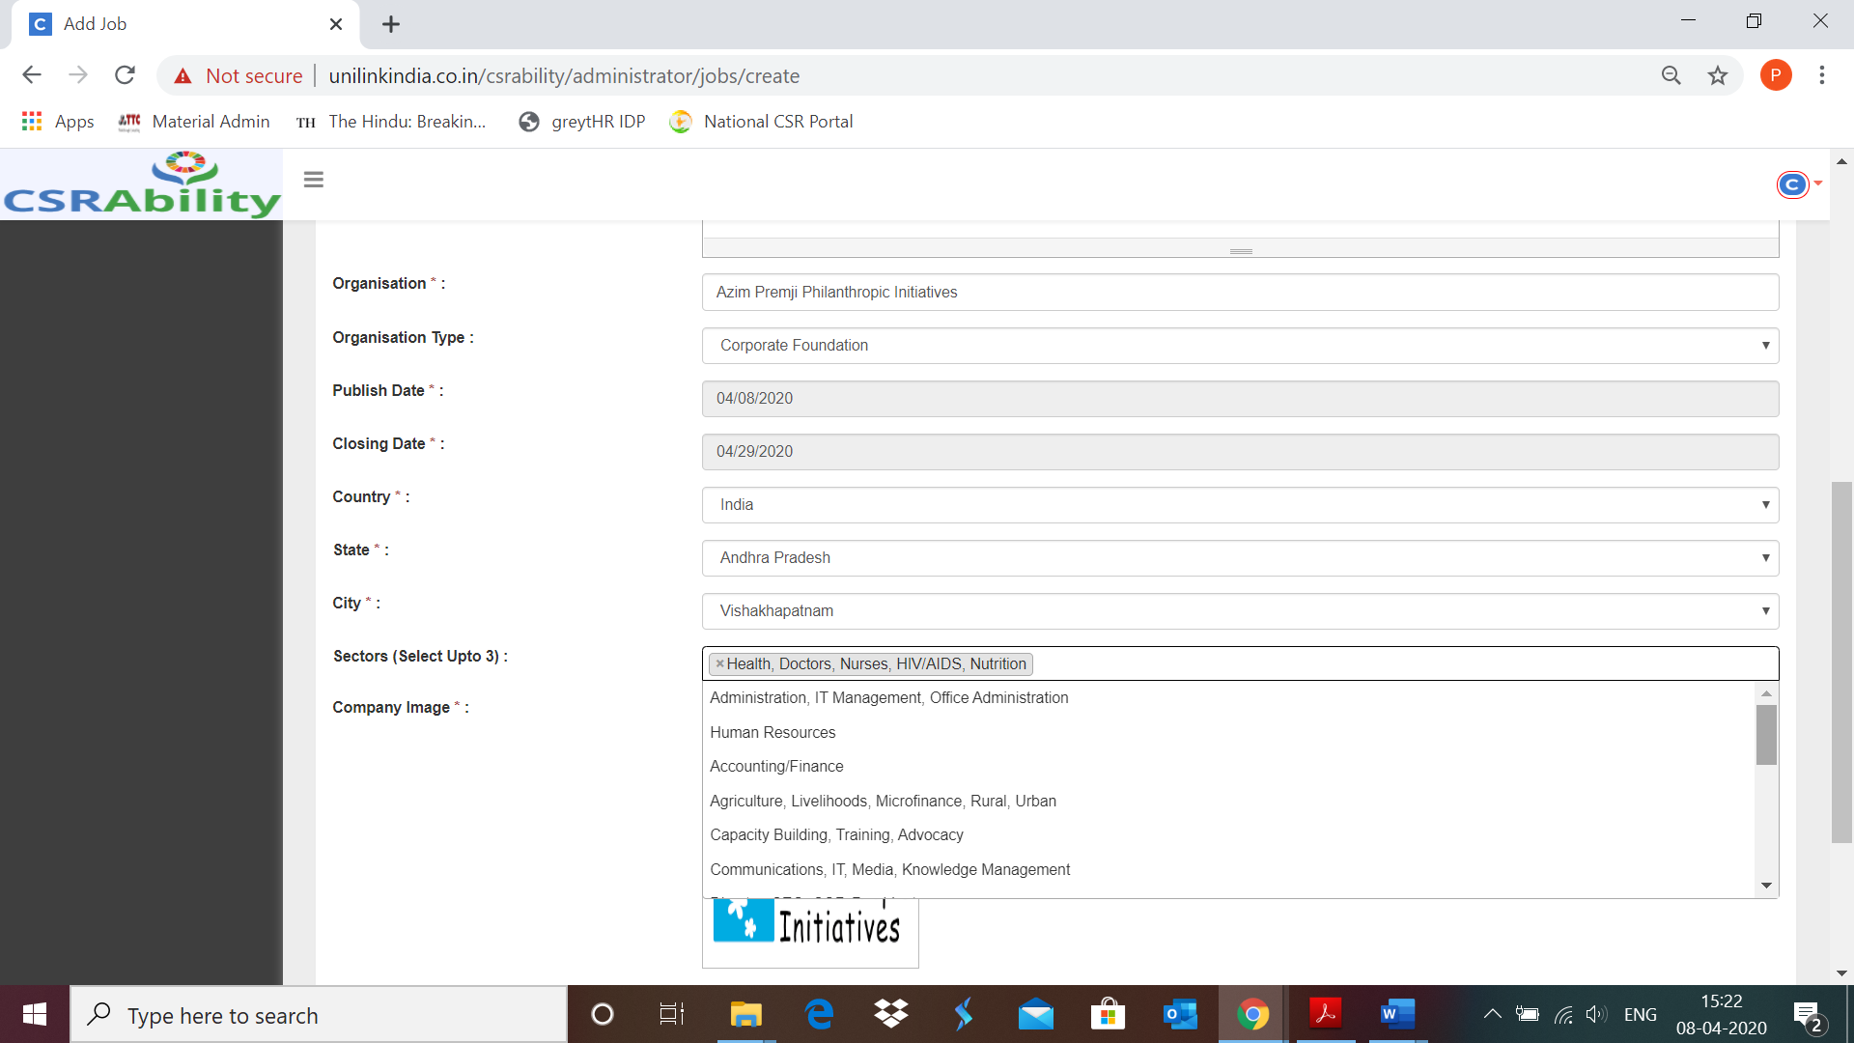
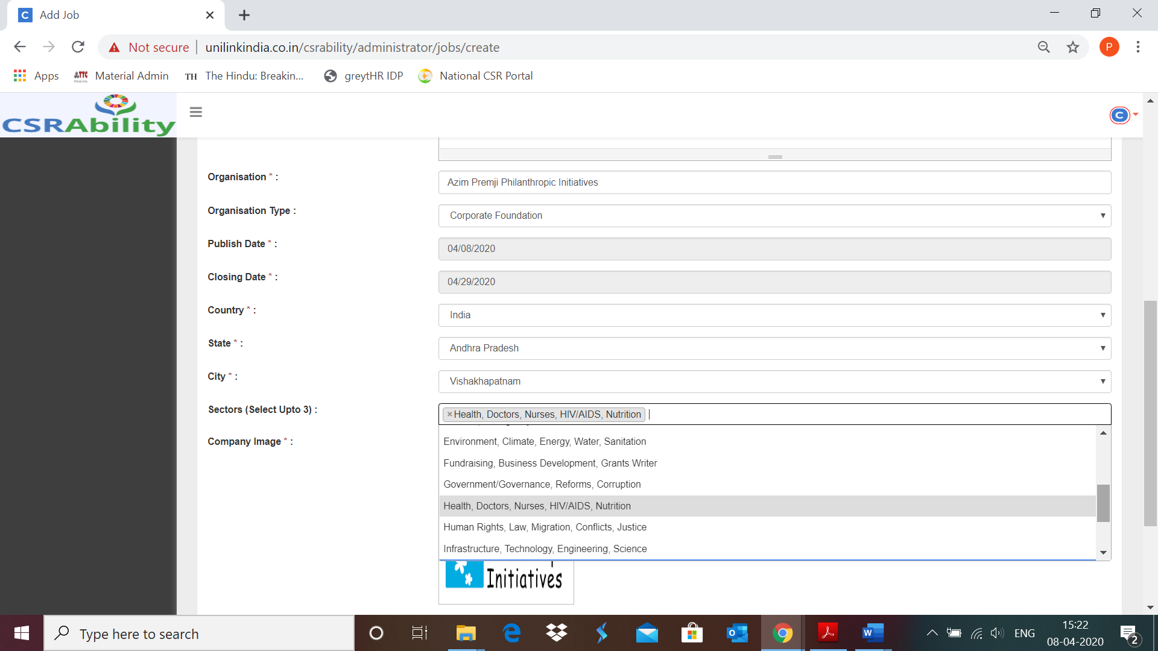
Can we provide all themes/sectors individually?
- On selecting the image to be uploaded, ‘image uploaded successfully’ message needs to pop up (the same way as is done for RFPs)

- Under ‘Organization Type’, INGO needs to be added
- An optional field for attaching documents/templates, if any, needs to be provided
- After uploading job details from the initiator login, I logged in from sub admin to approve the same. To approve the jobs, I followed both the steps mentioned below:
- Jobs New Jobs
- Clicked on ‘Activate’ on the ‘Congratulations! You have 4 new Jobs Post! Activate’ pop up.
Under both the options, below mentioned message appeared on the screen:
