UNICEF
Purpose Of The Assignment
Media has been a supportive partner in creating positive awareness, in dissemination of accurate information through editorial reporting and in influencing participation of communities in critical public health campaigns through positive and well researched reporting.
However, with paradigm shift in media landscape and with emergence of convergence news room and new age media, the ubiquitous media continues to play a crucial role in addressing vaccine hesitancy among urban and rural areas, in creating public trust about the value of vaccines and swiftly countering misinformation that spreads on social media platforms.
The purpose of the assignment will be:
- Sustain media engagement for building positive discourse on immunisation across all platforms of print, TV, online and magazines to build enabling environment for IMI 2.0 programmes especially in states implementing IMI. Number of positive editorials or articles or TV news generated covering immunisation story.
- Create adaptable and responsive creative content for leveraging digital news media platforms to counter spread of vaccine related rumours.
- Cultivate network of influencers to write author/op-ed articles for supporting positive public discourse about immunisation resulting in restoring vaccine trust.
- Establish and leverage strategic media partnerships resulting in better awareness for immunisation programmes.
- Plan crisis communication in media based on stakeholder inputs’.
Objectives

The specific objective of the media outreach will be to sustain and deepen positive awareness about IMI 2.0 campaign and support in creating an enabling environment for maximum participation in the campaign.

- Positive visibility for IMI 2.0 in traditional media: Develop and design a realistic and measurable media outreach plan to engage with traditional media (Print, TV, Online, Radio) for IMI 2.0 programme with an objective to create better public discourse leading to maximum participation. This includes stories from states; two media field visits.
- Develop innovative strategy to engage with new age media like digital platforms, mobile platforms and news apps to positively influence target beneficiaries. Adapt ground content for online news and mobile platforms.
- Support crisis communication in media during Adverse Event Following Immunization from districts and state. Analyse the nature of crisis communication for immunization in media and develop a responsive plan to mitigate a crisis communication plan in media during IMI 2.0 programme. Broadly there are two types of crisis communication. 1. Crisis due to programme issues 2. Crisis due to unfounded rumours in media. Agency is expected to manage the spread of rumour in media that may adversely impact participation of community in IMI 2.0 programme.

Major Tasks to be accomplished

Develop an achievable and specific media outreach plan for the campaign. | - Develop Media Outreach calendar  - Mapping of possible challenges or threats  - Preparing media collaterals  - Identifying influencers to support the campaign
Implement media outreach plan across all  formats in traditional and new age media. | - Develop research-based content  - Customize content for specific mediums  - Outreach to media for maximum visibility
Prepare media dossier and reports in line with campaign's expectation. | - Prepare analytical reports on media coverage

Technical approach and methodology

Our Approach
Target reach-out especially in UP and Bihar along with media hubs across target states – wherein there is an increased number of left-outs, dropouts, and resistant families, ethnically sensitive areas, urban slums, nomadic sites, migrant & underserved population and tribal / remote areas.

The Overriding Messages that need to be communicated
- Focus on lack of awareness among both citizens and health workers
- Dispel fear around immediate side-effects such as fever and misinformation about vaccines, migration of families and refusal to get vaccinated
- Positive information in layman’s language using media tools like articles, stories, infographics etc.
  - IMI 2.0 - 12 types of vaccines of which 10 will be used throughout the country: immunisation against TB, pertussis, tetanus, polio, diphtheria, measles, rubella, hepatitis-B, meningitis and pneumonia caused by Haemophilus influenza type B and rotavirus.
  - The other two – Japanese encephalitis vaccine and pneumococcal conjugate vaccine – will be administered in areas where these diseases are prevalent.
  - All four are important to complete the schedule - Completing the immunization schedule.

Objective - PR campaign IMI 2.0
- Creating and spreading positive media visibility leading to increase in awareness.
- Intensified outreach of accurate information via media, new age media, influencers community leaders.
- Address lack of awareness about the benefits of immunisation.
- Sustained outreach across key media hubs pan India elaborating on success stories, benefits, dispelling doubts and positive discourse on immunization.
- Crisis preparedness.

Our Methodology
Strategy
- Media Outreach Plan a across Print, Online, Electronic, Radio and New Media
- Crisis Communication plan to pre-empt and dispel negative effects of misinformation, negative sentiment and campaign and rumours.

Overall Strategy – Sustained Media Campaign
- UNICEF requires positive visibility, spread across different people outreach channels and collaborative push with target media houses. Therefore, we would like to suggest two pronged approach
  - Strengthen messaging / initiatives, efforts, positive message through PR push
  - More visibility/call to action (for positive & increased coverage) through Digital & Social Media
  - Spread use of new media tools– Influencers, Bloggers and Social platforms, digital communication via Videos, infographics, Cartoons, Comic Strips
  - One on one messaging using Media Partnerships – identify local leaders, influencers, celebrities, teachers, doctors and engage them to communicate with the people
  - Localised content in regional languages

Media Universe Mapping
This includes Newspapers, Magazines, Electronic Media, Radio Stations, Online Publications, Blogs, Video platforms
- Identify and map the media according to reach - readership and circulation and popularity
- Media to be mapped in two parts – National and Regional with respect to target states and cities
- Special tools to be identified like the ‘Zile ka Hulchul’ program of All India Radio
- Leverage the trained district radio stringers (training ongoing since last three years by UNICEF)

Content to include
- Progress Reports on the goal of Mission Indradhanush - ensure full immunization with all available vaccines for children up to two years of age and pregnant women.
- Stories with hard facts and statistics to educate people
  - Information on Benefits of completing step schedule towards full immunization
  - Dispelling myths around vaccinations - what you need to know
  - “The most misunderstood life-saving health intervention”
  - “A safe and free intervention that builds defence against life-threatening diseases in children”
  - Helped to eradicate diseases like small-pox and polio from India, and saved lives of millions of children and adults around the world.
- Elaborate the communication campaign ‘Paanch Saal, Saat Baar’ (5 saal, 7 baar) across relevant media channels (editorial support to be initiated with the media houses)
- RI as a national health priority – The chain to ensure health for all
  - Benefits of immunization and the stringent processes of cold chain, procurement, capacity building to make vaccines safe for use.

PR Outreach Tools
Create a Media Outreach calendar with Timelines outlining the key messages / outreach tools and target cities. The tools will be:
- Spokesperson Interactions: face to face / telephonic / email
- Media Briefings / Roundtables:
  - Across key Tier 2 media hubs (involving leading towns in each state)
  - Smaller media hubs in districts to be targeted for press releases
- Influencing the Influencer: Map 1-2 important influencers across each category and initiate partnerships / collaborations
  - Regional Media
  - Regional Bloggers and Popular Online Platforms
  - Identify and initiate advocacy with media houses who have the widest reach in the said districts
  - Consumer Connect Campaigns – celebrity endorsement
- Content Outreach:
  - Authored Articles / Blogs
  - Profiling of success stories
  - FAQs and Field Stories
  - Consumer Connect across digital platforms via cartoons, infographics, videos
  - Press Releases / Notes – propagate and spread across public via media tools – new initiatives and campaigns, immunization drives, street plays, special sessions, influencer endorsements and success cases, videos, wall writings etc.
- Industry:
  - Been seen and heard in the right channels
  - Views expressed – panel discussion, Speaker opportunities, awards
- Tactical PR on relevant days: like 7th April- World Health Day, 15th May - International Day of families, 8th March - International Women's Day, 14th March - World TB Day, 25th April - World Malaria Day among other relevant days
- World Immunization Week (24th-30th April, 2020): Use it to take to build awareness pan India by distribution information kits, celebrity brand ambassadors, sportsmen to promote immunization drive through special bands, walk for immunization for a healthy tomorrow, media panel discussions on the topic, ringtone with a vaccination awareness message, posters, vaccination booths with a house-to-house campaign for remote communities, unveil a report on state of immunization in the country
- Monthly focus: Create a PR plan to promote all the different diseases and the need for immunization against them covered by IMI 2.0 through a monthly calendar – Share factsheets/testimonials/case studies from different states with media, doctor and influencer interviews, myths vs facts listicles, panel discussions/focused write-ups to create awareness.
- Focused quarterly reports with infographics on states which are ahead in the IMI2.0 drive with statistics to encourage the push from states to make the drive a success.
- Factsheets and features on cold chain management system to be shared with media
- Local NGO/partner tie -ups to extend outreach to eb highlighted in local media through media briefings/roundtables/releases
- Media Content Preparation and support:
  - Key Spokespeople/Doctors Profiles
  - Knowledge Series - information booklets
  - Research / Reports / Data to supplement talks, roadshows, endorsements and collaborative campaigns
  - Testimonials/case studies to reach out to the media for features
  - Factsheets on IMI, cold chain management system, all diseases covered under the immunization drive
  - Presentations for advocacy with different influencing groups

Risk Assessment
Being Crisis Ready
Initiate extensive work as per following steps to ensure we are covered when the crisis hits
- Crisis Readiness Audit for Risk Assessment
- Communication Training @Crisis Situation
- Mock exercises at regular intervals
- Crisis Manual up-dation with case studies/field reports, holding statements…
- 24x7 monitoring and reports

The Essential Steps
STEP 1: Reputation Vulnerability Assessment
- A session will be conducted with key stakeholders:
- With inputs from the stakeholders, areas would be identified where UNICEF needs to be ready
- A mapping of pressure groups and subsequent strategy to deal with them
STEP 2: Audit Process
- Interviews of people to assess people readiness and skill set audit
- Audit of the approach to crisis
STEP 3: CRISIS COMMUNICATION TRAINING
- The training will equip the organization to cover:
- How to pre-empt crisis
- How to prevent crisis (if possible)
- How to protect UNICEF’s reputation

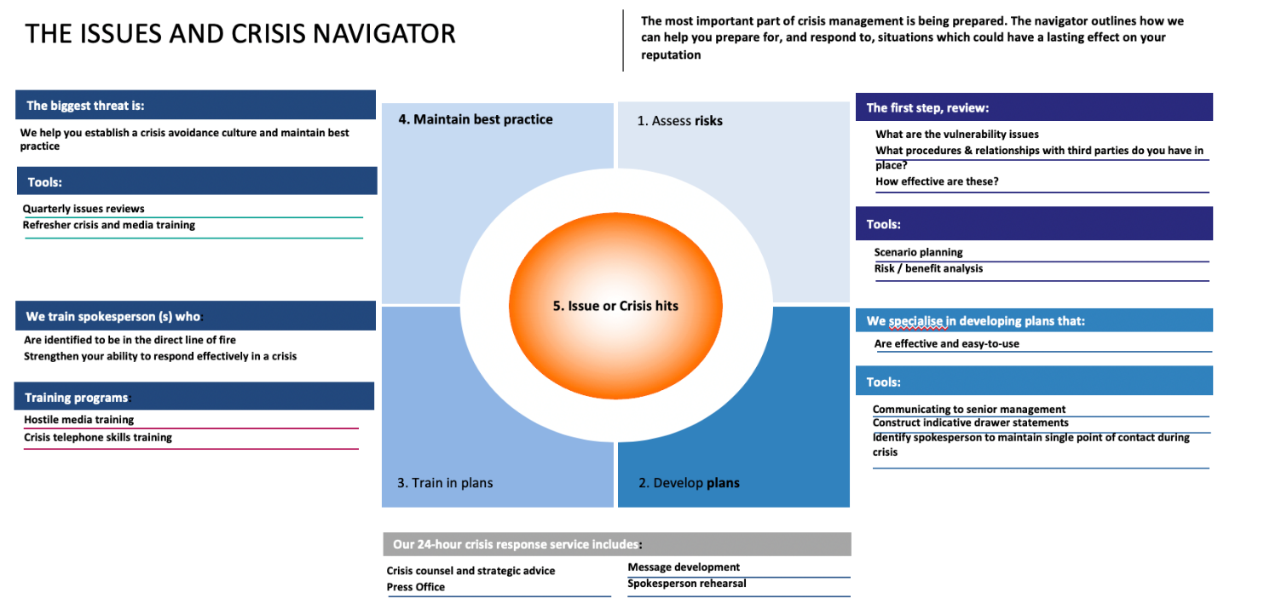

Media Training for Spokespersons
- The TEAM
  - Our media training team has years of experience training clients in how best to handle interactions with the media. Members of our team have worked are experts with on-ground media experience at very senior levels.
  - The Media Training Workshop is a highly interactive and intensive workshop, which includes mock interviews in a real studio environment to give the participants a feel of the actual interview setting.
- The Module
  - Our module and trainers are experienced Media persons / Senior Journalists / Public Relations specialists who have the working experience with Media across categories and blue-chip organizations.
  - This experience ensures that we understand the language of clients, knowledge of working with publications, journalists, and discussions that take place within boardrooms

Digital Plan
OBJECTIVE:
- Provide solutions for news dissemination, media monitoring and analysis, social listening with campaign monitoring. The purpose is to disseminate news, stories & conversations on social media and digital PR.
- Monitor & listen to such conversation in digital and social media that are relate to UNICEF and its work on children’s rights, to follow related stories and conversations in real time, to provide with valuable insight into what is being said about the organization, and to help in engaging with key audiences on various issues. Understand target audiences and tailor communication and advocacy strategies to be deployed on digital & social media.
- Identify and recruit influencers and create conversations around global issues related to UNICEF's mandate, keeping its digital community engaged in dynamic, interactive and meaningful ways.
- Measure the effectiveness of digital media efforts and prepare immediate response on key conversations

SERVICES:
- Digital & Social PR, SOCIAL LISTENING AND DIGITAL MONITORING & ANALYTICS
- The analytics/reporting solution for social listening and digital monitoring should include:

- Create weekly and monthly social media editorial plans.
- Provide content based campaign to be published on social media platforms.
- Provide tonality based content across several platforms including Facebook, Instagram Twitter, LinkedIn etc.
- Lead the creation and publishing of evidence-based social media content
- Manage social media editors and their editorial outputs and the moderation of all social media platforms.
- Foresee and analyze risk as it relates to digital engagement and protecting the UNICEF brand.
- Design and coordinate multiple social media initiatives with the aim of breaking down complexities of issues and humanizing UNICEF's voice.
- A single integrated platform for analyzing social media and digital content from multiple sources—including major networks such as Facebook, Twitter, Instagram, YouTube.
- Real-time access to information, data and insights related to UNICEF’s work, brand, reputation, programmatic priorities, humanitarian emergencies, campaigns and initiatives in multiple languages globally
- Monitor brand image and reputation, to help ensure that UNICEF’s values are well communicated and understood among key audiences. This includes providing a 360-degree view of brand (conversations, key audiences, amplifications, etc.) through social listening and key brand protection features like alerts, sentiment analysis, real-time brand listening, issue detection etc.
- Monitor and analyse hashtags, keywords, topics, and channels including data and analytics on reach, engagement, share of voice, sentiment, trending posts, etc.
- Identify potential influencers that could amplify UNICEF’s voice and message
- Create customized dashboards for real-time monitoring of topics
- Provide access to historic data (minimum 1 year of historic data)
- Spot emerging trends with real-time social listening
- Generate reports with key trends and insights to present to management teams at UNICEF

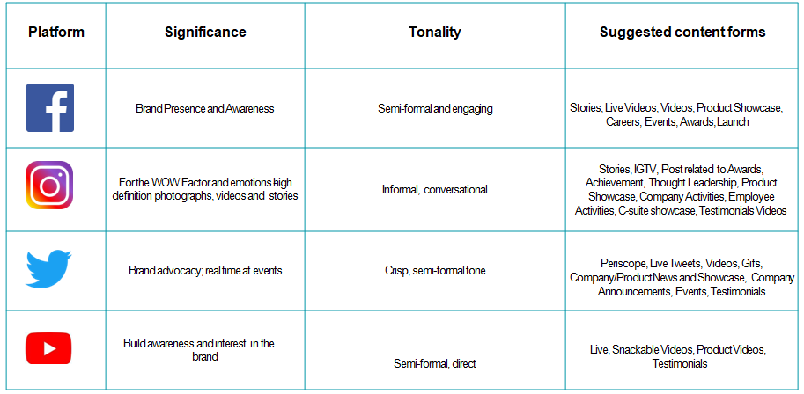
- Conversation Tonality on Social Channels:

Crisis Preparedness Template on Social Media:
- Step 1: Define Crisis
  - What scope of reach/impact should an event have to call it a crisis?
  - How severe does a situation need to be to consider it a crisis?
- Step 2: Define Priorities
  - What is the most important outcome of your crisis management?
  - List primary & secondary goals here.
- Step 3: Identify your audience
  - Who are the audiences for your primary goal?
  - Who are the audiences for your secondary and minor goals?
- Step 4: Kommune experts define core message
  - Kommune will define scope of reach/impact should an event have to call it a crisis?
  - How severe does a situation need to be to consider it a crisis?
- Step 5: Set Processes
  - Kommune will setup network-specific guidelines for communicating on social media
  - Kommune will suggest on a processes for communicating updates via your website and other online social channels.
- Step 6: Write templates
  - Kommune will write template for your initial response - this is the brief statement Kommune will draft ASAP acknowledging the situation.
  - Kommune will craft update templates for key stakeholders.
- Step 7: Measure & Reflect
  - Kommune will create reports on overall perception of brand & brand sentiments, over time?
  - Define University specific KPI’s for crisis
- Step 8: Create long-term plan
  - Plan about long-term conversations.
  - Plan on continual updates long-term audiences.

Processes & Measurement
- Daily News Summary
- Quarterly roll-out schedule
- Monthly Activity Sheet
- Weekly Work in Progress
- Monthly Coverage Analysis

Measurement – Qualifying PR efforts with quantitative metrics and business value involves
- Deliverables achieved
- Key message analysis
- Quantitative & Qualitative mapping
- Client / Media feedback
- Success of each program

Coverage Docket with Cross Channel PR Measurement qualifying the following
- Reach
- Impressions
- Engagement
- This involves AVE / VI mapping across Print and Online media along-with key messaging analysis, ROI Tracking and Increase in circle of influence

Work Plan and Schedule
Media Outreach Plan

GIZ

  - Approach and Methodology
Objectives of the Project
As per the Terms of Reference (ToR), the objectives of this assignment are:
- To capture the overall journey of the Umbrella Programme on Natural Resources Management (UPNRM), its design and programme-based approach (of blended finance), and innovations
- To identify best practices adopted as part of UPNRM, spanning different sectors and sub-sectors in NRM
- To capture the project impact (socio-economic and environmental)
- To assess the scope of up-scaling, replication potential and opportunities, key learnings and way forward with respect to mainstreaming

The key deliverables for this engagement include a holistic documentation of the UPNRM journey, displaying learnings and results, along with case studies of 36 programme supported projects working across different NRM themes and in various regions of India. The broad themes of projects identified by GIZ and NABARD for documentation include:
- Sustainable Agriculture
- Efficient Irrigation
- Processing/ Agro processing/ Agro waste management
- Agro Forestry
- Organic Farming
- Integrated Animal Husbandry
- Integrated Fisheries
- Livelihood Activities
- MAP/ NTFP development
- Marketing Support
- Forest Eco-tourism
In order to execute this engagement, we propose an approach comprising of four distinct phases consisting of several activities leading to outcomes and deliverables as per the Terms of Reference. Our approach has been presented below:
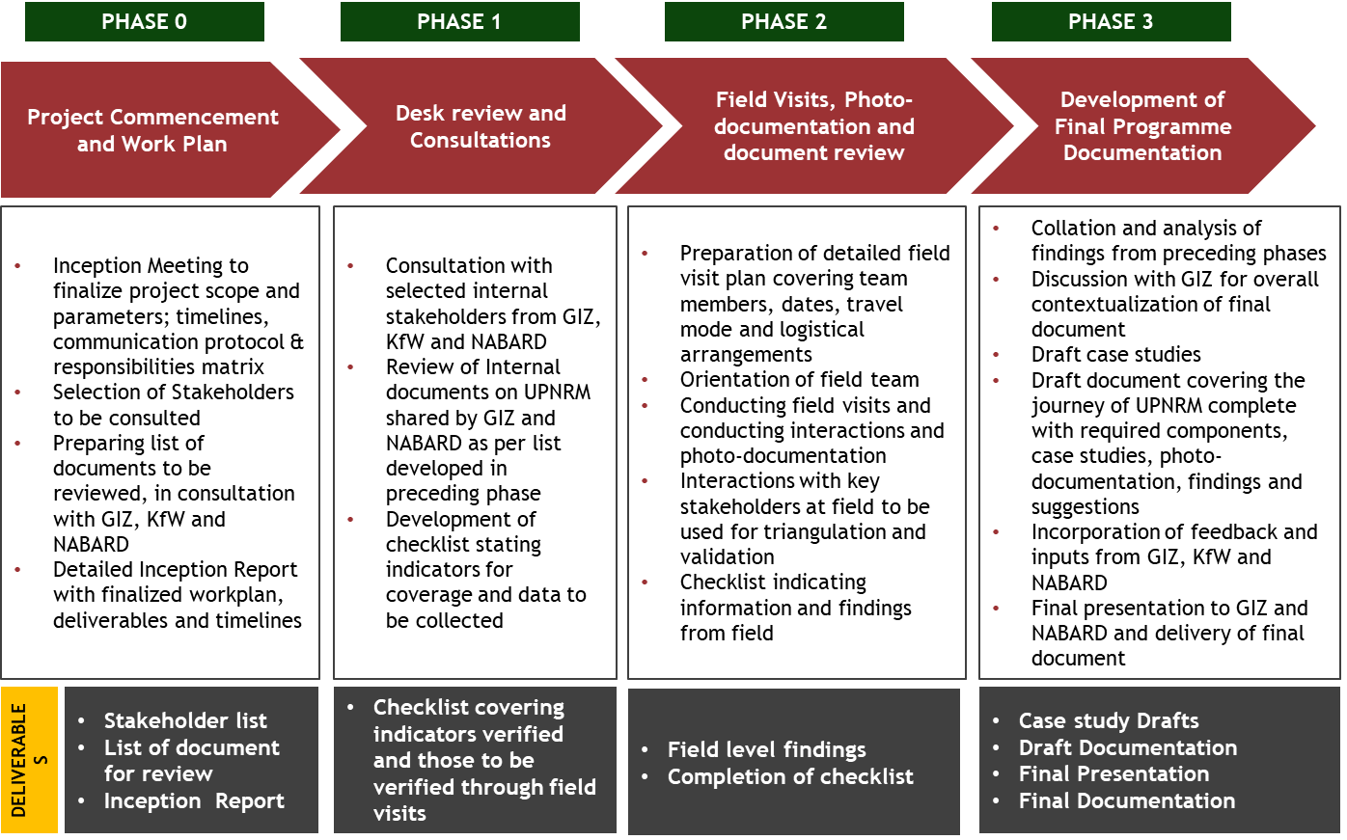

  - Detailed Methodology
Phase 0: Project commencement and work plan
Objectives:
- To set the context for the engagement along with GIZ in terms of expectations, deliverables, approach, timeline, communications, protocol and responsibilities;
- To identify a list of stakeholders to be consulted in discussion with GIZ and NABARD, both internal to the project and at the field sites;
- To identify a list of documents that would need to be reviewed in order to complete the assessment in consultation with GIZ and KfW;
- To develop the Inception Report highlighting the strategy, approach & methodology and final timeline and deliverable schedule.
Methodology:
Activity 1: Inception Meeting
An inception meeting will be held with GIZ a week after the signing of the contract. The meeting will be significant in bringing all the stakeholders on the same page vis-à-vis objectives of the project. The meeting will also led to finalizing the methodology to be deployed for collecting information from field and subsequent phases of data analysis and report writing. At the inception meeting, dates for stakeholder consultations/ field travel to project sites and submission of deliverables will also be finalized. This will help ensure timely facilitation of logistics and coordination. The meeting will also help identify internal and external stakeholders who will be consulted in order to collect programmatic and project information. These stakeholders will include key personnel from GIZ, KfW and NABARD as well as other stakeholders, including beneficiaries, at the project level. .
Soon after the inception meeting a detailed work plan will be developed and shared with GIZ. This work plan will contain updated timelines, roles and responsibilities of team members and key requirements for successful completion of the engagement. Further a preliminary stakeholder mapping will also be undertaken to identify both internal and external stakeholders. The table below provides an illustrative list of potential stakeholders
Figure 2: Illustrative list of potential stakeholders to be consulted
Internal Stakeholders
GIZ & KfW
- Head of the project
- Key team members, sector level coordinators and facilitators
- Key field personnel at the project level
- External consultants or advisors who played a key role during project conception or implementation
NABARD
- Personnel involved in the programme development, implementation and sanctioning of grant and loan based finance to different projects
External Stakeholders
- Project management staff
- Technical team and experts
- Direct beneficiaries
- Local NGOs and civil society organizations
- Local government officials
Additionally list of documents required for review both about the programme and those related to 36 case studies will be developed. Templates for the case studies and programme document, guidelines for desk review, data collection and photography will also be developed during this phase with inputs from Documentation and Technical experts, lead photographer and team leader, and GIZ.
Activity 2: Development of inception report
An inception report will be developed by TTC summarizing discussions with the various partners and highlighting the engagement strategy, methodology, final work plan and deliverables schedule. The inception report will provide a list of stakeholders to be consulted and a final list of documents to be reviewed/collected. The report will also include detailed table of content for both case studies and final documentation.
The draft report will be submitted to GIZ for their feedback, which will subsequently be incorporated in the final version of the inception report. Given below is an indicative outline of the inception report.
Indicative TOC for the inception report
- Section A: Introduction
  - Project background
  - Background and context
  - Objectives of the engagement and scope of work
- Section B: Detailed work plan including finalized documentation and case studies template, travel and logistics plan and desk review plan
- Section C: Roles and Responsibility matrix
- Section D: Timelines and Deliverables
- Section E: Risk Mitigation plan
Bibliography

Deliverables/Outcomes
- Detailed engagement strategy
- Inception Report

Phase 1: Desk review and consultations with internal programme stakeholders
Objectives:
- To review the documents collected from GIZ, KfW and NABARD;
- Consult internal stakeholders
- To collate and complete the literature review checklist

Methodology:
Activity 1: Development of literature review checklist
TTC understands that in order to capture relevant information during the desk review phase, a comprehensive literature review checklist needs to be developed. This checklist will outline both the broad and specific components of the UPNRM on which information needs to be collected.
Building upon the inception phase, the checklist will outline information and its source documents, programme partners from which knowledge material will be sourced from. An illustrative outline of the proposed checklist is given below.
Information | Documents/ material required for assessment | Collected (Yes/No) | Source | Internal stakeholders for interactions | Findings

Activity 2: Desk Review and interaction with internal stakeholders
Once the documents are identified and collected, a thorough desk review will be conducted by the team members, namely the technical experts, documentation expert, team leader, and support team members. The information from the literature review will collected in the checklist template and areas for further probing will be identified.
In order to ensure validity in the findings, the team will identify and conduct face- to- face interactions with internal stakeholders from GIZ, KfW and NABARD. These stakeholders will be mapped during the inception phase itself. The final set of findings will be fed into the checklist to complete the template. This completed checklist with findings will help identify key probe areas during the field visits (Phase 2)
The following table is an illustrative of how the complete checklist is expected to look like,

Figure 3: Documents tracker and checklist (ILLUSTRATIVE)
S. No. | Information | Documents/ material required for assessment | Collected (Yes/No) | Source | Internal stakeholders for interactions | Findings
1 | Background and context of the UPNRM programme | Knowledge and Policy papers on NRM and Livelihood | Yes | GIZ, NABARD | GIZ & KfW  - Head of the project  - Key team members, sector level coordinators and facilitators  - External consultants or advisors who played a key role during project conception or implementation  NABARD  - Personnel involved in the programme development, implementation and sanctioning of grant and loan based finance to different projects | - Programme Objectives and Motivation  - Milestones of the programme  - National and local policy context on issues covered by projects
1 | Background and context of the UPNRM programme | Programme Planning and Management documents | Yes | GIZ, NABARD
2 | Methodology for selection of 36 projects | Approach note | Yes | NABARD | GIZ & KfW  - Head of the project  - Key team members, sector level coordinators and facilitators | - Selection approach and process  - Project rationale  - Portfolio growth journey  - Geographical and subject coverage
2 | Methodology for selection of 36 projects | Performance reports, Project Assessment reports | Yes | GIZ, NABARD
3 | Relevance of UPNRM | Project background | Yes | GIZ, NABARD | GIZ & KfW  - Head of the project  - Key team members, sector level coordinators and facilitators  - External consultants or advisors who played a key role during project conception or implementation  NABARD  - Personnel involved in the programme development, implementation and sanctioning of grant and loan based finance to different projects | - Contribution of UPNRM to streamlining and up-scaling of Indo-German NRM efforts  - Background on overall lending, grant, CSR and round funding  - Socio-Economic and Environmental impact of programme interventions
3 | Relevance of UPNRM | Documents on blended finance | Yes | GIZ, NABARD
3 | Relevance of UPNRM | Knowledge and Policy papers on programme- related subjects | Yes | GIZ, other sources
4 | Key development and successes | Training Manuals | Yes | GIZ, NABARD | GIZ & KfW  - Head of the project  - Key team members, sector level coordinators and facilitators  - External consultants or advisors who played a key role during project conception or implementation  NABARD  - Personnel involved in the programme development, implementation and sanctioning of grant and loan based finance to different projects | - Growth journey of partnership between NABARD and GDC  - Portfolio details and growth  - Up-scaling and Replication  - Awards and recognitions  - International and national leverage of the Indo- German joint collaboration on NRM
4 | Key development and successes | Short movies Project fliers | Yes | GIZ
4 | Key development and successes | Progress reports | Yes | GIZ
5 | Challenges and ways forward | Programme performance reports | Yes | GIZ, NABARD | GIZ & KfW  - Head of project  - Key team members, sector level coordinators and facilitators  - External consultants or advisors who played a key role during project conception or implementation | - Risks and challenges faced and mitigation  - Handholding requirements  - Strategies for further mainstreaming of NRM and Climate Change concerns into credit financing portfolio of financial institutions  - Replication and scalability potential/ opportunities  - Overview of opportunities with various national and state governments, banks and financial institutions
5 | Challenges and ways forward | Assessment reports | Yes | GIZ, NABARD, other sources
*The checklist provided is an illustrative and does not represent the actual template, which will be finalized during the inception phase of the engagement

Deliverables/Outcomes
- Checklist covering indicators verified and those to be verified through field visits

Phase 2: Field Visits and Documentation Review at project level
Objectives:
- To cover UPNRM supported projects in terms of their background, theory of change, relevance, and project facts
- To photo-document components relevant for the overall documentation – Rationale (Problem), Project Staff, Interventions, Outcomes and Beneficiaries
- To validate and triangulate findings from Phase 1, and reflect on the overall UPNRM through project level achievements , challenges and opportunities
- To complete the checklist developed in Phase 1 and therefore complete the assessment
Methodology:
Activity 1: Development of tools and information collection template
For each of the 36 case studies, data collection tools will be developed for multiple stakeholders who will include project staff, local community members, government and civil society representatives.

Each tool will be carefully developed in consultation with GIZ, so as to ensure capturing of broad and specific information components of the project being covered. The documentation expert and team leader will supervise the development of Semi-Structured interview questions for interactions with project staff, key stakeholders from the community, channel partners, government and civil society; and Focus- Group Discussion checklists for beneficiaries. The team will also develop transect walk checklist. For a streamlined collection of data through interactions with different stakeholders and identifying knowledge documents, an information collection template will be developed to serve as both a checklist and an information gathering tool. Each team member will use this template to capture all relevant information. For photo-documentation, a separate checklist will be used.

Illustrations of the information collection, field observation and photo-documentation templates are provided below,

Project name
Agency
Sector
Information | Responses shared by project management prior to visit | Stakeholders for interaction | Findings from interactions | Documents for review | Findings from review

Observations from field | Stakeholders met | Photographer | Themes to be covered (Photo-documentation) | Photographed (yes/no)

Activity 2: Development of Field Visit Plan and Schedule
The project team will finalize the itinerary, logistics and a detailed field plan for the field visits after interacting with the 36 agencies shortlisted for documentation. Any changes required in the field plan developed during the inception phase will be communicated with GIZ.
For the field visits, the engagement team will divide the projects as per sector and region (zone-wise). Based on this categorization, a detailed field plan indicating visit schedule for different team members will be shared with GIZ. Careful consideration will be given to ensure efficiency in travel- time, and assigning of travel dates to technical experts, team leader, photographers, and documentation expert.
TTC proposes to categorize the 36 case studies into three categories. The categories will be on the basis of geographical zones - North and Western zone, Eastern zone, and Southern zone. Each zone will be covered by one team including technical expert and TTC’s zonal coordinator. The teams formed in such a manner will be able to cater to the varied geographical and socio-cultural differences since the zonal coordinators are from one of the states from the zone and have experience of working in that zone.
1. North and Western Zone

Figure 4: Number of projects (North and Western Zone)
North and Western Zone
Gujarat | 2
Maharashtra | 9
Rajasthan | 2
Uttarakhand | 1
Total | 14

2. Eastern Zone

Figure 5: Number of projects (Eastern Zone)
Eastern Zone
Bihar | 3
West Bengal | 2
Jharkhand | 1
Odisha | 3
Assam | 1
Total | 10

3. Southern Zone

Figure 6: Number of projects (Southern Zone)
Southern Zone
Andhra Pradesh | 3
Tamil Nadu | 3
Kerala | 1
Karnataka | 5
Total | 12

It is proposed that each team in each zone cover 9 cases summing it to 18 days per zone per team, assuming two days per case study. The remaining cases in each zone will be covered by the team leader (North and Western- 5; Eastern Zone- 1; Southern Zone- 3). The team leader will be accompanied by the documentation expert.
The 3 technical experts and team leader will cover 9 projects each, thereby covering all projects shortlisted for case studies. Given that each project will require 2 days to cover, a total of 72 person- days will be required to complete the field visits.

The final field plan for technical experts will be prepared in a manner so as to allow thematic allocation of projects, as well as ensuring cost and time- efficient regional coverage.
The schedule will include separate dates for consultations with beneficiaries, government officials and local civil society representatives. A risk mitigation plan will be incorporated in order to account for any invariable delays which may occur when travelling to remote locations. Travel modes (air/train/ road), precise departure and arrival points along with exact times will also be detailed in the plan. The project team will arrange for the logistics with support from GIZ where possible.

Activity 3: Conducting field visits, interactions and photo-documentation; Interactions with key stakeholders at field to be used for triangulation and validation
The field visits will cover three broad components in order to capture the projects comprehensively:
- Project Details – Information of the organization, Rationale and Relevance of the project, Journey, social, economic and environmental impact, Challenges and Learnings.
- Technical Details – Sector being addressed, Project approach and achievements and sector- specific innovations (if any)
- Photo-Documentation- Project geography, Project staff, Beneficiaries, Innovations, Implementation.
Based on previous consultation with GIZ and findings from the literature review checklist, TTC will share a project information- template with all agencies beforehand, requesting for general and specific information prior to the field visits. Based on the responses gathered, the team will be able to pin-point which information will have to be captured or probed further during the visits and from which stakeholders.
Moreover, prior to the field visits, a detailed training session will be kept with the field team, which will feature the documentation expert presenting the template of the case study and documentation, and instructions on what and how information will be gathered as per the information collection, field observation and photo-documentation templates. For the purpose of photo-documentation, the senior photographer will also brief the team on details and arrangements required for ensuring high standard in photography. This may include taking photographs during particular time of the day when natural lighting is appropriate and not too bright.
The team leader will brief the team on the timelines and deliverables from the field visit, and technical experts will train the field team on respective themes to ensure deeper understanding of projects during respective visits. Finally the team will also be trained on usage of tools.
The field team will proceed as per the finalized field-plan. In order to ensure any additional support, support team members from TTC will be present to conduct any pre/post-visit logistical or other support.
The field teams will first collect data and conduct consultations at the agency level before moving on to interactions with local community members (including beneficiaries), civil society and government representatives. In order to capture data, the team will utilize Semi-Structured Interviews with project staff, civil society members and local government representatives, and focused group discussions with project beneficiaries. The team will review all relevant documentation in the field
Information gathered during the visits will be collated using the predefined format, and shared with the documentation expert and team leader at the end of each project visit. The photographers will simultaneously proceed with photography of components related to project and impact, and utilize any travel time for processing of photos and sharing with documentation expert for feedback.
Field visits to the project sites will also include transect walks to inspect the activities carried out as part of the project. The field level interactions and observations will be used to triangulate and validate findings from the documents.
It is expected that each field visit will require 2 days to cover a project. Focus of the first day of the visit will include interactions with project staff members, collection of relevant documents, conducting interviews with any local government officials and civil society representatives. The second day of the visit will include transect walk of team and photographers for observation and photo-documentation, and conducting any FGDs or interviews with community members and beneficiaries.
Activity 3: Completion of information template
Upon review of project documentation and interactions at field with various external stakeholders, the findings will be collated into the project information template, against each of the general and specific project indicators. This template will subsequently be shared with GIZ for feedback, which will be incorporated. Illustrations of complete field observation and photo-documentation templates are provided below.
Figure 7: Field visit- monitoring, information and findings template (ILLUSTRATIVE)
Project name |  | Establishment of Modern Dairy Demonstration Farm (Mogar, Anand District)
Agency |  | Kaira District Cooperative Milk Producers’ Union
Sector |  | Marketing
Information |  | Responses shared by project management prior to visit | Stakeholders for interaction | Findings from interactions | Documents for review | Findings from review
GENERAL INFORMATION | Background of  agency | - Agency information  - Project information | - Project staff | Validation of responses shared by project management prior to visit | - Approach note  - Project implementation plan  - Financial documents  - Project MIS  - Progress Reports  - Other supporting documents | Validation and triangulation of findings from stakeholder interactions and observations
GENERAL INFORMATION | Geographies  covered by  intervention | - Geographical outreach | - Project staff  - Local Civil society and CBOs  - Government official  - Direct beneficiaries
GENERAL INFORMATION | Profile of  beneficiaries | - Beneficiary outreach | - Project staff  - Local Civil society and CBOs  - Direct beneficiaries
GENERAL INFORMATION | Channel partners | - Names of channel partners | - Project staff  - Representatives from partner agencies
GENERAL INFORMATION | Nature of support  and duration | - Grant/ Loan/ Project implementation period | - Project staff
GENERAL INFORMATION | Challenges and  Pitfalls | - Challenges faced during implementation phase  - Handholding support provided by UPNRM | - Project staff  - Representatives from partner agencies  - Local Civil society and CBOs
GENERAL INFORMATION | Impact | - Social, Economic and Environment Impact | - Project staff  - Local Civil society and CBOs  - Government official  - Direct beneficiaries  - Representatives from partner agencies
GENERAL INFORMATION | Recommendations  and opportunities | - Community acceptability and policy opportunities  - Scalability  - Future prospects
SECTOR SPECIFIC | Project rationale | - Objective and Theory of Change | - Project staff
SECTOR SPECIFIC | Relevance of project | - Local context  - Innovations  - Advantages in comparison to conventional approach | - Project staff  - Local Civil society and CBOs  - Government official  - Representatives from partner agencies
SECTOR SPECIFIC | Resulting Benefits of  association for the  project | - Result of UPNRM support for the project | - Project staff
SECTOR SPECIFIC | Project approach | - Implementation strategy and coverage strategy | - Project staff  - Representatives from partner agencies
SECTOR SPECIFIC | Policy environment | - Policy context at different levels | - Project staff  - Local Civil society and CBOs  - Government official  - Representatives from partner agencies
SECTOR SPECIFIC | Project performance | - Milestones and achievements | - Project staff  - Representatives from partner agencies
*Template is illustrative and will be finalized during the inception phase of the engagement. Template will be created for each project
Figure 8: Field visit- monitoring, information and findings template (Transect walk and Photo-documentation) (ILLUSTRATIVE)
Transect walk conducted (Yes/ No) | Stakeholders met | Observations | Photographer | Themes for Photo-documentaion | Photographed (yes/no)
Yes | - Beneficiaries  - Panchayat members  - Local Civil Society representatives | - Project impact  - Acceptability of project  - Relevance of the project  - Local context in terms of intervention | Ritu Bharadwaj | - Social, Economic and Environmental impact  - Beneficiary profile  - Innovation and interventions  - Project staff and location  - Local surroundings to validate context and relevance of activity | Yes
*Template is illustrative and will be finalized during the inception phase of the engagement. Template will be created for each project
Deliverables/Outcomes
- Project level documentation review
- Project photo-documentation
- Findings from stakeholder interaction
- Completion of checklist

Phase 3: Development of Final Programme Documentation
Objectives:
- To develop the Programme Documentation incorporating information collected during preceding phases
- To finalize case studies which will form a part of the documentation
- Present and deliver final programme document to GIZ

Methodology:
Activity 1: Data Collation, Quality Review and Analysis
Phase 2 (Field visits) will be implemented in a manner which allows for regular feedback from GIZ on the data gathered, using checklists. However, during Phase 3, information gathered will be collated and reviewed thoroughly by team members on 3 broad grounds:
- Accuracy of general information- Information pertaining to UPNRM journey and other components mentioned in the TOR, Project information
- Technical accuracy of information- Sector and project specific information pertaining to implementation and processes, impact, innovations, challenges and learning; broad sectorial context
- Format related- Whether information and photo-documentation has been gathered as per guidelines (as detailed in phase 2), and checklists.
This process will allow for contacting any relevant internal or external stakeholder in case information gaps are identified and allow for a structured data analysis. The data analysis and findings will be structured in a manner so as to feed into the proposed structure of the final report
Subsequent to completion of collation of analysis, a preliminary presentation of findings from phase 1 and 2 will be conducted for GIZ. Any feedback provided will be incorporated.
Activity 2: Development of Draft Documentation and Case Studies
Based on the findings and recommendations developed in Phase 1 and the critical review of the findings from Phase 2, the project team will develop a draft impact assessment report. An indicative outline of the draft report has been presented below
Indicative TOC for the final documentation
- About the Umbrella Programme on Natural Resources Management (UPNRM)
  - Background and context
  - Objectives of the programme
  - Partners of the programme
  - Different Support mechanism as part of UPNRM
  - Structure and process of the programme
- Project Outreach and Impact
  - Overall Journey and Key Milestones
  - Relevance of the programme
  - Supported sectors and interventions
  - Beneficiary and geographical outreach and profile
- UPNRM impact
  - Streamlining Climate Change and NRM in the financial sector
  - Key innovations in different sectors
  - Key social, economic and environmental outcomes and impact
  - Leveraging and Supporting existing policies and initiatives
- Challenges and opportunities
  - Local contexts and challenges
  - Major implementation challenges faced
  - Risk Management and Mitigation strategies adopted
  - Uniqueness of the initiatives and financial support strategy
  - Sustainability and Replicability of initiatives
- Case studies
  - Methodology of selection of projects
  - Project details*^
    - About the project
    - Project rationale
    - Relevance of supported activities
    - Project facts
    - Approach of the project
    - Success factors and challenges
    - Impact of the project
    - Recommendations and opportunities
- Mainstreaming and way forward
- Bibliography

*Individual Projects
^Relevant photographs within the each case study

A final review of the documentation and case studies will be conducted by the team leader, technical experts, and documentation expert. The copy-editor will ensure that tone, language and terminologies are as per the standards agreed to between GIZ and TTC during project commencement stage. Additionally, the copy-editor and documentation expert will also review and curate the final creatives of the documentation. Draft documentation with case studies will be shared with GIZ for their feedback.
Activity 3: Development of Final Report and Presentation
The project team will incorporate GIZ’s feedback and develop the final version of the documentation on the journey of UPNRM along with the 36 finalized case studies. The final documentation and case studies will also be converted into a presentation for GIZ and NABARD.
Deliverables/Outcomes
- Draft Case studies
- Draft Documentation
- Final Presentation
- Final Documentation with case studies

  - Work Schedule
Our work schedule reflects our Approach and Methodology and has been provided below:

S.No. | Activity/Timeline | Month 1 |  |  |  | Month 2 |  |  |  | Month 3 |  |  |  | Month 4
S.No. | Activity/Timeline | W1 | W2 | W3 | W4 | W5 | W6 | W7 | W8 | W9 | W10 | W11 | W12 | W13 | W14 | W15 | W16
1 | Phase 0
 | Inception meeting
 | Selection of stakeholders and document review list
 | Development of inception report
2 | Phase 1
 | Development of Checklist
 | Desk review and Consultation with internal stakeholders
3 | Phase 2
 | Finalization of field visit plan and tools
 | Field Visit and Photo-documentation
 | Completion of information template
4 | Phase 3
 | Data Collation, Quality review and Analysis
 | Preliminary presentation on findings
 | Development of Draft Documentation and Case studies
 | Final report and Presentation

