Caribpay Report :
- Tested the flow with Ankit, everything was fine.
- Below issue found till
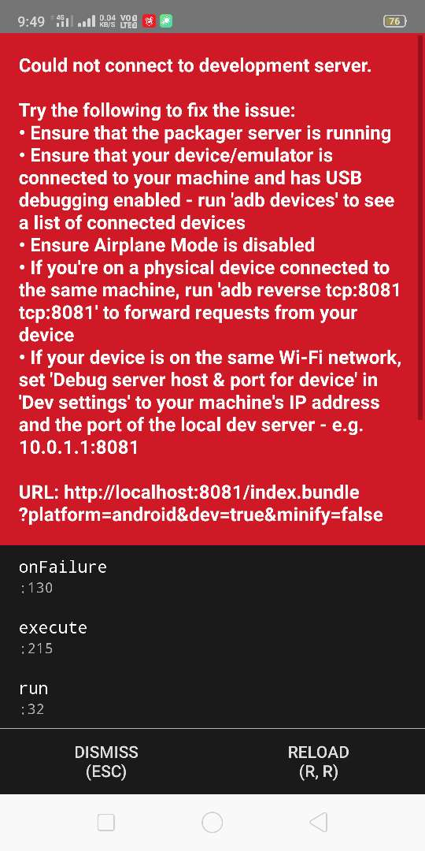
After fixing the issue, he shared the new APK,
Issues :
1. Notification count is not removing (read/unread not working)
2. Google API for address not working in Add Address.

